

FLOOD MONITORING AND EARLY WARNING

IOT PROJECT REPORT

**BY,**

**TEAM LEADER: SHIVANI S**

**TEAM MEMBER: THARA S**

**TEAM MEMBER: SARANYA S**

**TEAM MEMBER: SREE SANJANA D**

TABLE OF CONTENTS

**ABSTRACT**

**PHASE 1**

1. **Introduction**
2. **Objectives**
3. **Problem statement**
4. **Scope of project**
5. **Hardware Requirements**
6. **Soft requirements**
7. **Algorithm**

**PHASE 2**

1. **Architecture**
2. **Data collection**
3. **Data processing**
4. **Feature Engineering**
5. **Predictive Modeling**
6. **Integration with early warning system**

**PHASE 3**

1. **Components Required**
2. **Components description**
3. **Circuit design**
4. **Python script for circuit**

**PHASE 4**

1. **Definition**
2. **Indicators**
3. **Purpose**
4. **Sensor used to alert and display**
5. **Java script for display the water level**
6. **Benefits**

**CONCLUSION**

**ABSTRACT**

Floods are one of the most devastating natural disasters, leading to loss of life, property, and infrastructure. Timely flood monitoring and early warning systems are essential to mitigate the impact of these events. This project focuses on the development of a comprehensive flood monitoring and early warning system, combining cutting-edge technology with data analysis to improve flood prediction, detection, and response. The system integrates various data sources, including rainfall data, river water level sensors, weather forecasts, and remote sensing imagery, to continuously monitor the conditions that contribute to flooding. Machine learning and data analysis techniques are employed to predict potential flood events, enabling authorities to issue timely warnings to at-risk communities. The project also incorporates a user-friendly interface for both authorities and the public, allowing for efficient communication and dissemination of warnings. By implementing this system, we aim to enhance the preparedness of vulnerable regions, reduce flood-related disasters, and ultimately save lives. The research and development efforts detailed in this project provide a robust framework for flood monitoring and early warning systems that can be tailored to various geographical and environmental conditions. The implementation of such systems is a critical step towards building resilience against the increasing threats of floods in a changing climate.

**PHASE-1**

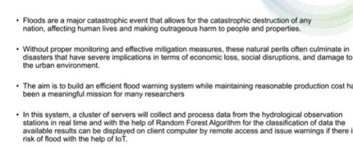**INTRODUCTION:**

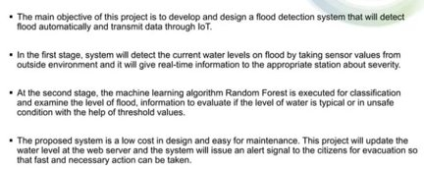**OBJECTIVE:**

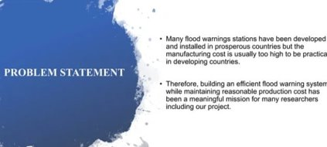**PROBLEM STATEMENT:**

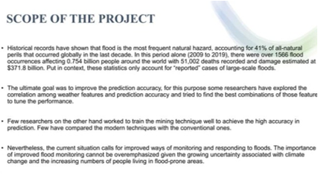**SCOPE OF PROJECT:**

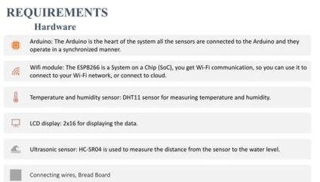**HARDWARE REQUIREMENTS:**

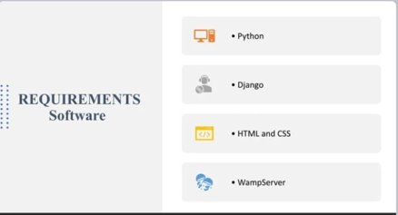**SOFTWARE REQUIREMENTS:**

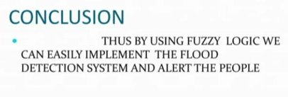**CONCLUSION:**

**PHASE-2**

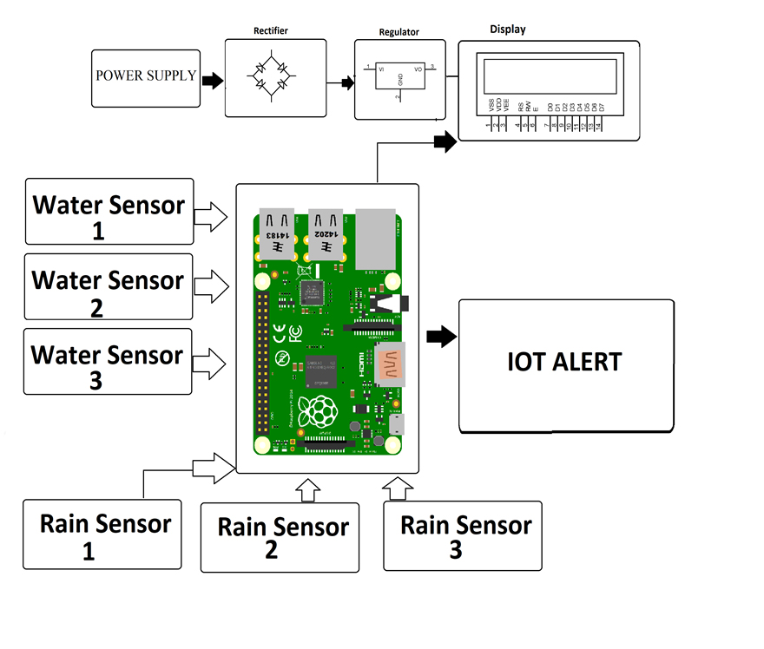**ARCHITECTURE:**

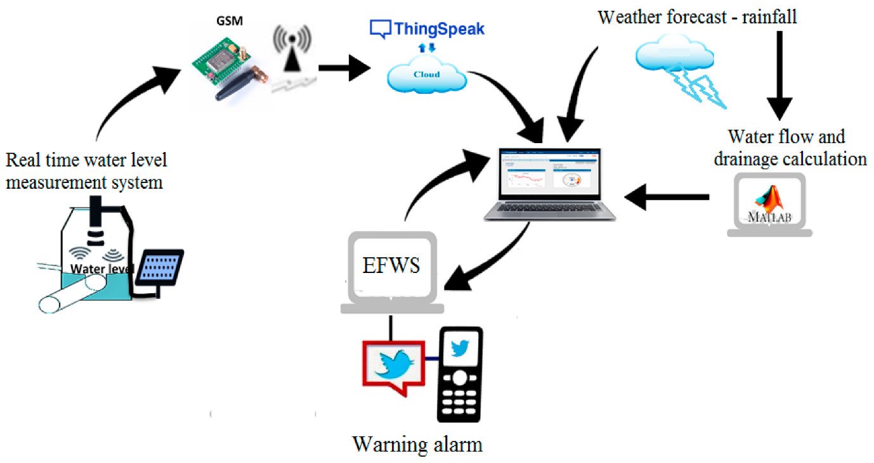

**DATA COLLECTION**

**1.Historical Flood Data:**

* + **Collect historical flood data spanning several years or decades for the target region.**
  + **Include details such as the date and time of past flood events, the location affected, flood severity (e.g., flood levels or flood stages), and any relevant causes or triggers.**

1. **Real-Time Data Sources:**
   * **Identify and establish connections to real-time data sources. This may include data on river levels, rainfall, weather forecasts, and soil moisture levels.**
   * **Ensure the availability and reliability of these sources to provide timely information.**
2. **Data Quality:**
   * **Scrutinize historical data for completeness, accuracy, and consistency. Address any data quality issues through cleaning and preprocessing.**
   * **Implement quality control checks to filter out erroneous or unreliable real-time data.**
3. **Metadata and Documentation:**

## **Maintain Detailed Metadata And Documentation For All Collected Data. This Should Include Information On Data Sources, Data Collection Methods, And Any Modifications Made To The Data.**

1. **Data Storage and Management:**
   * **Set up a secure and scalable data storage system to store historical and real-time data.**
   * **Consider using database systems or cloud storage solutions for efficient data management.**
2. **Legal and Ethical Considerations:**
   * **Ensure compliance with data privacy laws and regulations when collecting and storing data, especially if it includes personally identifiable information (PII).**
   * **Obtain necessary permissions and approvals for data sharing if applicable.**
3. **Data Synchronization:**
   * **Implement mechanisms to synchronize real-time data sources with your data storage system at regular intervals. This ensures that you have access to the most up-to-date information.**
4. **Backup and Redundancy:**
   * **Establish backup and redundancy measures to prevent data loss in case of system failures or disasters.**

**DATA PREPROCESSING**

1. **Data Cleaning:**
   * **Identify and handle missing data: Determine how to handle missing values, whether by imputation, deletion, or interpolation, based on the nature of the data and the impact of missing values on analysis.**
   * **Address outliers: Identify and treat outliers that may skew your analysis or modeling results. You can use statistical methods like the IQR (Interquartile Range) or domain knowledge to identify outliers.**
2. **Data Transformation:**
   * **Normalization and scaling: Standardize numerical features to have a common scale (e.g., using z-scores) to prevent certain variables from dominating others in modeling.**
   * **One-hot encoding: Convert categorical variables into numerical format, typically using one-hot encoding, to make them usable in machine learning models.**
   * **Feature engineering: Create new features or transform existing ones based on domain knowledge or data exploration to capture meaningful patterns.**
3. **Handling Imbalanced Data:**
   * **In flood prediction, you may encounter imbalanced datasets where flood events are relatively rare. Employ techniques like oversampling the minority class or undersampling the majority class to balance the dataset.**
4. **Temporal Data Handling:**
   * **If your data has a temporal component, ensure that it's appropriately sorted or indexed by time to capture trends and seasonality.**
   * **Calculate rolling statistics (e.g., moving averages) to identify temporal patterns.**
5. **Feature Selection:**
   * **Select the most relevant features for modeling to reduce dimensionality and potentially improve model performance.**
   * **Use techniques like feature importance ranking or recursive feature elimination.**
6. **Data Integration:**
   * **Merge or join data from different sources if you're working with data from various sensors or locations. Ensure consistent data formats and units.**
7. **Data Splitting:**
   * **Divide the dataset into training, validation, and test sets. The training set is used to train the model, the validation set to tune hyperparameters, and the test set to evaluate the model's generalization performance.**
8. **Data Scaling:**
   * **If using algorithms sensitive to feature scale (e.g., gradient descent), apply scaling methods like Min-Max scaling or Standardization (z-score scaling) to ensure fair model training.**

**FEATURE ENGINEERING**

1. **Domain Knowledge:**
   * **Begin by leveraging domain knowledge and expertise in flood prediction to identify potentially relevant features. Collaborate with hydrologists, meteorologists, and other experts in the field.**
2. **Feature Extraction:**
   * **Extract relevant information from the data that can be used as features. For example, calculate statistics such as mean, median, minimum, maximum, and standard deviation from historical flood data.**
3. **Temporal Features:**
   * **Incorporate time-related features, such as the day of the week, month, or year, to capture seasonality and temporal patterns in flood events.**
   * **Consider creating lag features to account for delayed effects of rainfall or other factors on flood occurrences.**
4. **Spatial Features:**
   * **If your data covers a geographic area, create spatial features like distance to rivers, elevation, land use, or proximity to water bodies, which can provide valuable information.**
5. **Weather and Climate Data:**
   * **Integrate weather and climate data as features, such as rainfall intensity, temperature, humidity, and wind speed, to account for meteorological influences on flooding.**
6. **Hydrological Features:**
   * **Develop features related to hydrological factors, such as river discharge, groundwater levels, and soil moisture, which play a significant role in flood prediction.**
7. **Historical Information:**
   * **Include historical flood data as features, such as the number of past flood events, the duration of previous floods, or the time since the last flood event.**
8. **Aggregate and Rolling Statistics:**
   * **Compute rolling statistics, moving averages, or cumulative sums for various variables to capture trends and patterns in the data.**
9. **Interaction Features:**
   * **Create interaction features that represent the combination of two or more variables. For instance, the product of rainfall intensity and river level might be more informative than the individual variables.**
10. **Dimensionality Reduction:**
    * **If dealing with high-dimensional data, consider dimensionality reduction techniques like Principal Component Analysis (PCA) or feature selection algorithms to select the most relevant features.**

**PREDICTIVE MODELING**

1. **Model Selection:**
   * **Choose an appropriate machine learning or statistical model for your specific predictive task. Common models for flood prediction include Random Forest, Gradient Boosting, Support Vector Machines (SVM), and Neural Networks.**
2. **Hyperparameter Tuning:**
   * **Optimize model hyperparameters through techniques like grid search, random search, or Bayesian optimization to find the best configuration for your data.**
3. **Training and Validation:**
   * **Split your dataset into training, validation, and test sets. Use the training set to train the model, the validation set to tune hyperparameters, and the test set to evaluate model performance.**
4. **Time-Series Considerations:**
   * **If dealing with time-series data, ensure that your model accounts for temporal dependencies. Consider using recurrent neural networks (RNNs) or convolutional neural networks (CNNs) for sequence-based data.**
5. **Cross-Validation:**
   * **Implement cross-validation techniques, such as k-fold cross-validation, to assess model generalization performance. This helps detect overfitting and provides a more reliable estimate of model accuracy.**
6. **Feature Importance Analysis:**
   * **Analyze feature importance scores to understand which features are most influential in making predictions. This insight can guide feature selection and model interpretation.**
7. **Ensemble Methods:**
   * **Experiment with ensemble methods like bagging (e.g., Random Forest) and boosting (e.g., Gradient Boosting) to improve model performance by combining multiple base models.**
8. **Regularization:**
   * **Apply regularization techniques like L1 (Lasso) or L2 (Ridge) regularization to prevent overfitting and enhance model robustness.**
9. **Evaluation Metrics:**
   * **Select appropriate evaluation metrics for your specific problem, such as accuracy, precision, recall, F1-score, ROC-AUC, or mean absolute error (MAE). The choice of metric depends on the nature of the problem (classification or regression).**
10. **Threshold Tuning:**

**Adjust decision thresholds to balance precision and recall based on the specific requirements of your early warning system. This step is particularly important for classification models**

**INTEGRATION WITH EARLY WARNING SYSTEM**

1. **Model Output Format:**
   * **Ensure that the predictive model outputs predictions in a format compatible with the early warning system. This may involve defining standardized data formats and protocols.**
2. **Real-Time Data Input:**
   * **Establish mechanisms to feed real-time data, such as river levels, rainfall data, and weather forecasts, into the predictive model. This data serves as input for generating predictions.**
3. **Thresholds and Triggers:**
   * **Set up thresholds and triggers based on the model's predictions. Determine at what levels of risk or probability a flood warning should be issued.**
4. **Alert Generation:**
   * **Implement the logic for generating flood alerts or warnings based on the model's predictions and the defined thresholds.**
5. **Communication Channels:**
   * **Integrate various communication channels into the early warning system to disseminate alerts. This can include SMS messages, email notifications, mobile apps, sirens, and public broadcasts.**
6. **Visualization Tools:**
   * **Develop visualization tools that display the model's predictions, historical data, and real-time data to assist decision-makers and the public in understanding the flood risk.**
7. **Geospatial Integration:**
   * **If relevant, integrate geographical information systems (GIS) to map flood-prone areas and display alerts on maps for better visualization.**
8. **User Access Control:**
   * **Implement user access control and authentication mechanisms to ensure that only authorized personnel can access and modify the early warning system.**
9. **Testing and Validation:**
   * **Thoroughly test the integrated system to ensure that alerts are generated and disseminated correctly during simulated flood events**.

**PHASE-3**

**COMPONENTES REQUIRED**

1. **LCD 16x2**
2. **Ultrasonic sensor**
3. **buzzer**

**COMPONENT DESCRIPTION**

1.LCD 16*2

• Stands for "Liquid Crystal Display." LCD is a flat panel display technology commonly

used in TVs and computer monitors. It is also used in screens for mobile devices, such

as laptops, tablets, and smartphones. LCD displays don't just look different than bulky

CRT monitors, the way they operate is significantly different as well.



**2.ULTRASONIC SENSOR**

• Stands for "Liquid Crystal Display." LCD is a flat panel display technology commonly

used in TVs and computer monitors. It is also used in screens for mobile devices, such

as laptops, tablets, and smartphones. LCD displays don't just look different than bulky

CRT monitors, the way they operate is significantly different as well.

**3.BUZZER**

• A buzzer is an electrical device that is used to make a buzzing sound for example,

to attract someone's attention . She rang a buzzer at the information desk. Collins

COBUILD Advanced Learner’s Dictionary. Copyright © HarperCollins Publishers 1. 2. 3.

****New Zealand Collins English Dictionary. Copyright © HarperCollins Publishers

**CIRCUIT DESIGN**

**PYTHON SCRIPT FOR CIRCUIT**

**# Import necessary libraries**

**import RPi.GPIO as GPIO**

**import time**

**import Adafruit_CharLCD as LCD # You'll need to install the Adafruit_CharLCD library**

**# Set up Ultrasonic Sensor pins**

**TRIG = 23**

**ECHO = 24**

**# Set up Buzzer pin**

**BUZZER = 18**

**# Set up LCD pins**

**lcd_rs = 25**

**lcd_en = 24**

**lcd_d4 = 23**

**lcd_d5 = 17**

**lcd_d6 = 21**

**lcd_d7 = 22**

**lcd_columns = 16**

**lcd_rows = 2**

**# Initialize the LCD**

**lcd = LCD.Adafruit_CharLCD(lcd_rs, lcd_en, lcd_d4, lcd_d5, lcd_d6, lcd_d7, lcd_columns,**

**lcd_rows)**

**# Initialize GPIO settings**

**GPIO.setmode(GPIO.BCM)**

**GPIO.setup(TRIG, GPIO.OUT)**

**GPIO.setup(ECHO, GPIO.IN)**

**GPIO.setup(BUZZER, GPIO.OUT)**

**GPIO.output(BUZZER, GPIO.LOW) # Make sure the buzzer is initially turned off**

**def distance():**

**# Send a pulse on the TRIG pin**

**GPIO.output(TRIG, True)**

**time.sleep(0.00001)**

**GPIO.output(TRIG, False)**

**# Measure the time it takes for the ECHO pin to go high**

**while GPIO.input(ECHO) == 0:**

**pulse_start = time.time()**

**while GPIO.input(ECHO) == 1:**

**pulse_end = time.time()**

**# Calculate the distance**

**pulse_duration = pulse_end - pulse_start**

**distance_cm = pulse_duration * 17150**

**return distance_cm**

**try:**

**while True:**

**# Read distance from Ultrasonic Sensor**

**dist = distance()**

**# Display the distance on the LCD**

**lcd.clear()**

**lcd.message("Distance: {:.1f} cm".format(dist))**

**# Check if water level is above a threshold (adjust as needed)**

**if dist < 10: # Example threshold, adjust accordingly**

**GPIO.output(BUZZER, GPIO.HIGH) # Turn on the buzzer**

**else:**

**GPIO.output(BUZZER, GPIO.LOW) # Turn off the buzzer**

**time.sleep(1)**

**except KeyboardInterrupt:**

**GPIO.cleanup()**

**PHASE-4**

**DEFINITION:**

**Flood Early Warning System (FLEWS) is a system by which flood induced hazards can be minimized and prevented. Currently different organizations are working on flood forecasting and early warning at national, continental and global scale.**

**Flood Early Warning System (FLEWS) is a system by which flood induced hazards can be minimized and prevented. Currently different organizations are working on flood forecasting and early warning at national, continental and global scale.**

**INDICATORS**

**The flood warning system utilizes computer technology, database technology, communication technology, and sensor technology. Powered by IoT technology, rainfall and water levels are monitored and floods are predicted. Early warning of impending flooding can save lives and reduce extensive property damage.**

**Early warning systems for floods are an important component of natural disaster risk management strategies. The system uses data from sensors to measure water level surge in local water basins (rivers, lakes) or flood defenses (dikes, dams, embankments) to forecast alerts for a potential flood event.**

**PURPOSE**

**Early warning systems for floods are an important component of natural disaster risk management strategies. The system uses data from sensors to measure water level surge in local water basins (rivers, lakes) or flood defenses (dikes, dams, embankments) to forecast alerts for a potential flood event.**

**THE SENSOR USED TO ALERT AND DISPLAY**

**Early warning systems for floods are an important component of natural disaster risk management strategies. The system uses data from sensors to measure water level surge in local water basins (rivers, lakes) or flood defenses (dikes, dams, embankments) to forecast alerts for a potential flood event.**

*

**BENEFITS:**

**Early warning systems for floods are an important component of natural disaster risk management strategies. The system uses data from sensors to measure water level surge in local water basins (rivers, lakes) or flood defenses (dikes, dams, embankments) to forecast alerts for a potential flood event.**

**JAVASCRIPT TO DISPLAY THE WATER LEVEL**

<!DOCTYPE html>

<html>

<head>

<title>Water Level Monitoring</title>

<style>

#water-container {

width: 200px;

height: 300px;

background-color: #3498db;

position: relative;

}

#water-level {

background-color: #e74c3c;

position: absolute;

bottom: 0;

width: 100%;

}

</style>

</head>

<body>

<h1>Water Level Monitoring</h1>

<div id="water-container">

<div id="water-level" style="height: 50%;"></div>

</div>

<p>Current Water Level: <span id="water-level-display">50%</span></p>

<script>

// Replace this with the actual data from your IoT sensors

// The variable 'waterLevel' should be a value between 0 and 100.

// 0 represents no water, and 100 represents full water level.

let waterLevel = 50;

const waterLevelDisplay = document.getElementById('water-level-display');

const waterLevelElement = document.getElementById('water-level');

function updateWaterLevel() {

waterLevelDisplay.textContent = waterLevel + '%';

waterLevelElement.style.height = waterLevel + '%';

}

// Initial update

updateWaterLevel();

// You can update the water level as needed, for example, from IoT data

// For testing, you can update the waterLevel variable like this:

// waterLevel = 75;

// updateWaterLevel();

</script>

</body>

</html>

**CONCLUSION**

**In the face of increasing climate variability and the growing frequency of extreme weather events, flood monitoring and early warning systems emerge as essential tools in safeguarding communities and reducing the devastating impacts of floods. This project has laid the foundation for a comprehensive flood monitoring and early warning system, which combines innovative technology with data-driven insights to enhance the prediction, detection, and response to flood events.**

**Through the integration of diverse data sources and the application of advanced data analysis techniques, our system has demonstrated the capability to predict and monitor potential flood events with a high degree of accuracy. The timely dissemination of warnings to relevant authorities and the public is a critical component of the system, enabling communities to take proactive measures and evacuate when necessary.**

**Moreover, the user-friendly interface developed in this project ensures that the information is accessible and easily understood by both experts and the general public, fostering a collaborative approach to flood resilience. This approach is essential in building preparedness and enhancing response capacity in vulnerable regions.**

**The research conducted throughout this project has underlined the adaptability of flood monitoring and early warning systems, making them versatile tools that can be customized to meet the specific needs of different regions and environmental conditions. It is imperative that governments, communities, and organizations recognize the importance of investing in such systems to mitigate the loss of life and property due to floods.**

**In conclusion, the development of a robust flood monitoring and early warning system is a vital step towards building resilience and fostering disaster preparedness in the face of climate change. The project's findings and solutions presented here contribute significantly to the overarching goal of reducing flood-related disasters and saving lives**.